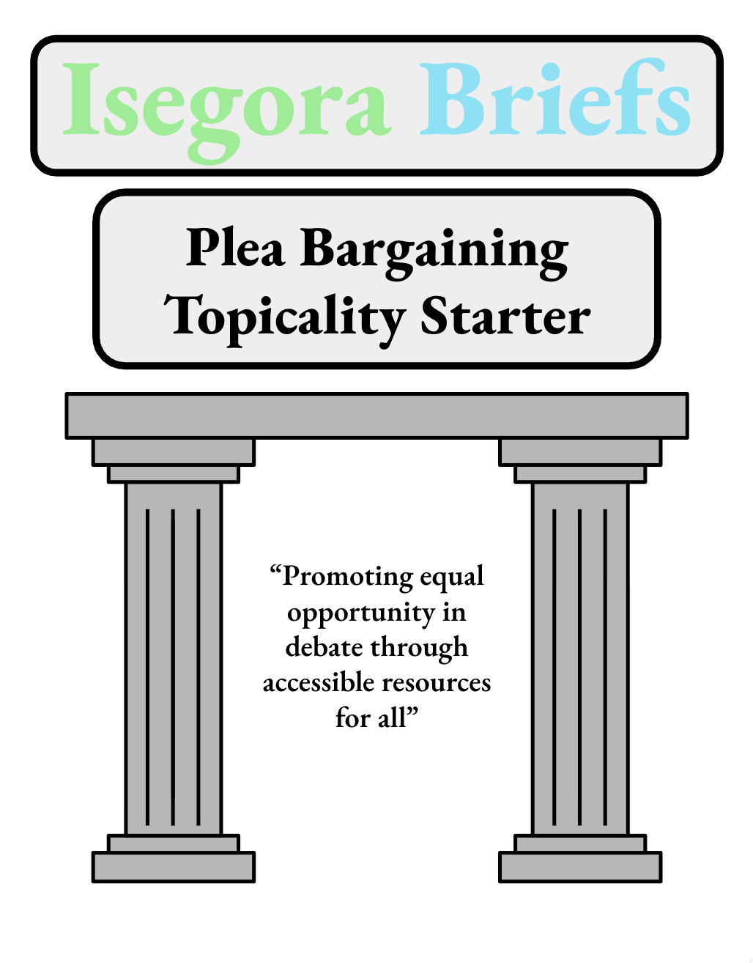

Isegora Briefs – Topicality Starter for 2025 Sep/Oct Plea Bargaining

We hope you find the following cards useful for starting your research on the resolution Resolved: In the United States criminal justice system, plea bargaining is just.

Contributors:
Kieran Finnegan

Criminal Justice System

Generic

The “Criminal Justic System” is responsible for fair trials and reducing crime.
Cocklin 77 [Cocklin, K R. “NCJRS Virtual Library.” FUNCTIONS OF CRIMINAL JUSTICE - PROCEDURES, TASKS AND PERSONNEL (FROM FUNDAMENTALS OF CRIMINAL JUSTICE - A SYLLABUS AND WORKBOOK, 1977, 2D ED., BY DAE H CHANG - SEE NCJ-44045) | Office of Justice Programs, 1977, www.ojp.gov/ncjrs/virtual-library/abstracts/functions-criminal-justice-procedures-tasks-and-personnel.] //Isegora
THE CRIMINAL JUSTICE SYSTEM CONSISTS OF THE POLICE, THE COURTS, AND CORRECTIONS. THE MAJOR TASKS OF THE POLICE INCLUDE SELECTIVELY ENFORCING THE LAW, POTECTING THE PUBLIC, AREESTING SUSPECTED LAW VIOLATORS, AND PREVENTING CRIME. THE COURTS ARE RESPONSIBLE FOR ASSURING THAT SUSPECTED CRIMINALS RECEIVE FAIR TRIALS AND FOR DETERMINING THE GUILT OR INNOCENCE OF THE ACCUSED. THE GOAL OF THE CORRECTIONAL SUBSYSTEM IS TO REHABILITATE OFFENDERS OR TO ALTER THEIR BEHAVIOR SO THAT THEY ARE SOCIALLY ACCEPTABLE AND LAW ABIDING. THE GOAL OF ALL THREE SUBSYSTEMS IS THE REDUCTION OF CRIME IN THE COMMUNITY. ALTHOUGH THERE EXISTS A SERIES OF STEPS FOLLOWED BY PERSONS WHO ENTER THE CRIMINAL JUSTICE PROCESS, THE ISSUE OF WHETHER THAT PROCESS REFLECTS THE UNITY OF PURPOSE IMPLIED BY THE TERM 'SYSTEM' REMAINS CONTROVERSIAL. THE ROLES AND RESPONSIBILITIES OF PERSONNEL WITHIN THE POLICE, COURTS, AND CORRECTIONS SUBSYSTEMS ARE REVIEWED. INCLUDED ARE DISCUSSIONS OF POLICE ORGANIZATIONS, CRIME SCENE RESPONSIBILITIES OF THE POLICE, POLICE CHAIN OF COMMAND AND AGENCY DIVISIONS, COURT STRUCTURE, SELECTION OF JUDGES, AND THE FUNCTIONS OF PROSECUTORS, DEFENSE ATTORNEYS, OTHER COURT PERSONNEL, JURIES, CORRECTIONAL OFFICERS, PROBATION OFFICERS, AND PAROLE OFFICERS. CHARTS DEPICTING THE ORGANIZATION OF A MUNICIPAL POLICE DEPARTMENT AND THE MOVEMENT OF CASES THROUGH THE CRIMINAL JUSTICE SYSTEM ARE PROVIDED. A BIBLIOGRAPHY AND A CHAPTER TEST ARE INCLUDED.

Plea Bargaining

Generic

“Plea Bargaining” is the act of agreeing to plead guilty for reduced punishment.
LII [“Plea Bargain.” Legal Information Institute, Legal Information Institute, www.law.cornell.edu/wex/plea_bargain. Accessed 1 Aug. 2025.] //Isegora
Many successful criminal prosecutions in the United States end not with jury trials, but with plea bargains. Plea bargains are agreements between defendants and prosecutors in which defendants agree to plead guilty to some or all of the charges against them in exchange for concessions from the prosecutors. These agreements allow prosecutors to focus their time and resources on other cases, and reduce the number of trials that judges need to oversee.

Unconstitutional

“Plea Bargaining” is inherently unconsitutional.
LII [“Plea Bargain.” Legal Information Institute, Legal Information Institute, www.law.cornell.edu/wex/plea_bargain. Accessed 1 Aug. 2025.] //Isegora
Although plea bargaining allows the criminal justice system to conserve resources, the plea bargains are controversial. Some commentators oppose plea bargains, as they feel that plea bargains allow defendants to shirk responsibility for the crimes they have committed. Others argue that plea bargains are too coercive and undermine important constitutional rights. Plea bargaining does require defendants to waive three rights protected by the Fifth and Sixth Amendments: the right to a jury trial, the right against self-incrimination, and the right to confront witnesses. The Supreme Court, however, in numerous cases (such as Brady v. United States, 397 U.S. 742 (1970) has held that plea bargaining is constitutional). The Supreme Court, however, has held that defendants’ guilty pleas must be voluntary, and that defendants may only plead guilty if they know the consequences of doing so. McCarthy v. United States 394 U.S. 459 (1969).

Just

Moral

Being “just” is being morally good.
Merriam-Webster [“Just Definition & Meaning.” Merriam-Webster, Merriam-Webster, www.merriam-webster.com/dictionary/just. Accessed 1 Aug. 2025.] //Isegora
acting or being in conformity with what is morally upright or good

Fair

“Just” is fairness
Cambridge Dictionary[“Just | Definition in the Cambridge English Dictionary.” Cambridge Dictionary, Cambridge Dictionary, dictionary.cambridge.org/us/dictionary/english/just. Accessed 1 Aug. 2025.] //Isegora
fair; morally correct:

In

General

“In” shows inclusion.
Merriam-Webster [“In Definition & Meaning.” Merriam-Webster, Merriam-Webster, www.merriam-webster.com/dictionary/in. Accessed 9 Aug. 2025.] //Isegora
used as a function word to indicate inclusion, location, or position within limits

Is

General

“Is” is the present tense of be.
Collins Dictionary[“Is Definition in American English | Collins English Dictionary.” Collins Dictionary, Collins Dictionary, www.collinsdictionary.com/us/dictionary/english/is. Accessed 6 Aug. 2025.] //Isegora
Is is the third person singular of the present tense of be1 and be2. Is is often added to other words and shortened to -'s.

